Board Members

- Advisor
Mr. Manoj Paudel



MSc from London School of Economics where he was a Chevening Scholar Chairperson/Executive Committee Member of the Investment and International Affairs Forum at the Federation of Nepalese Chambers of Commerce and Industry (FNCCI)

- Er. Tapendra Chand
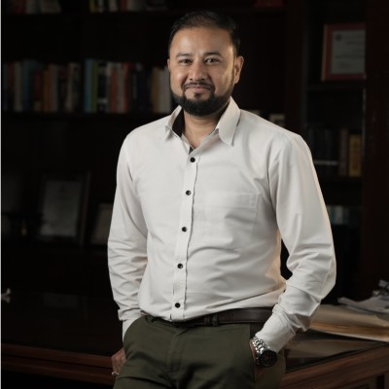
Tapendra is a highly experienced professional in the field of renewable energy, with over 11 years of dedicated work in energy systems, infrastructure planning, and public-private partnerships. He holds a Master’s in Energy Systems from FH Aachen University in Germany and a bachelor’s in industrial engineering from Thapathali Campus, Institute of Engineering (IOE), Nepal. He is also an APMG (CP³P) Certified PPP Professional, adding to his strong credentials in infrastructure project development and financing.
As Director at Invest and Infra Pvt. Ltd., Tapendra specializes in evidence-based program development and stakeholder engagement for clean energy and infrastructure initiatives. His work focuses on structuring and promoting sustainable energy projects that are technically sound, financially viable, and aligned with national and provincial development goals. In his previous role as a consultant at the Office of the Investment Board Nepal (OIBN), he was instrumental in managing large-scale solar and hydroelectric projects, conducting in-depth technical and financial due diligence, and contributing to strategic national infrastructure studies. He was a core team member for the study determining the financial modality and project configuration for the West Seti and SR6 hydroelectric projects, and he also contributed to the study on financial close extension for the 900 MW Upper Karnali Hydroelectric Project. His work further extended to industrial planning, including involvement in the study for establishing a chemical fertilizer plant in Nepal and preparing pre-feasibility study reports on solid waste and agricultural projects presented at the Nepal Investment Summit 2019. For his significant contribution to national infrastructure planning and his dedication to the Office of the Investment Board Nepal, he was honored with a Token of Appreciation from the Rt. Honorable Prime Minister of Nepal.
Beyond his work at OIBN, Tapendra contributed to the development of provincial-level renewable energy plans for Bagmati and Gandaki Provinces while working with Wind Power Nepal. At PEEDA (People, Energy & Environment Development Association), he played a leading role in the design and development of innovative energy projects and concept notes, including solar-powered cold storage systems, hybrid solar-biomass and solar-wind systems, pico-hydro technologies, and climate change adaptation projects linked to sustainable livelihoods. His academic journey also includes research at Forschungszentrum Jülich in Germany, where he further deepened his expertise in advanced energy systems during his master’s thesis.
Tapendra's extensive experience, both in the field and at the policy level, positions him as a leading figure in Nepal’s transition toward sustainable, inclusive, and resilient energy systems

- Snigdha Shah

Snigdha is a results-oriented professional with a background in Finance and Marketing. She holds an undergraduate degree from Kathmandu University and a Master’s degree in Marketing from Lincoln University. Over the past five years, she has worked with the Federation of Nepalese Chambers of Commerce and Industry (FNCCI) and Invest and Infra (now IXI Corp), focusing on project planning and organization, people management, partnership development, and outreach. Her experience spans both the private and development sectors, with a strong grasp of stakeholder coordination and internal operations. In addition to her project roles, she has also overseen administrative and operational functions at a group company, further building her skills across business management.
- Praharsh Malla

Praharsh Malla is an experienced entrepreneurial professional with a strong background in strategic planning, operations management, and stakeholder engagement. He began his career as a Sales and Marketing Officer at Society International, where he was responsible for developing and executing sales strategies, managing client relationships, and launching targeted marketing campaigns. He also conducted in-depth market research to identify emerging trends, analyze competitive dynamics, and understand customer behavior.
Currently, Praharsh serves as the Director of Hetish Krishi Farm, where he has led the growth of a sustainable agricultural enterprise. His work focuses on expanding market presence, improving operational efficiency, and ensuring regulatory compliance. His leadership in resource-based enterprise development provides a solid foundation for contributing to clean energy initiatives, particularly those connected to rural development and agri-energy integration.
Praharsh’s combined expertise in enterprise management and market development brings valuable insight to the energy sector, especially in advancing decentralized energy solutions and community-focused programs.

- Nischal Singh Bhandari

Highly skilled Communication Expert with years of experience in developing and executing effective communication strategies, cultivating strategic partnerships, and enhancing brand visibility. Proven track record in stakeholder engagement, media relations, and crisis communication. Strong project management abilities with a focus on driving impactful results. Passionate about Environmental, Social, and Governance (ESG) principles and integrating sustainability practices into communication strategies.
- Smritee Paudel

Smritee has over five years of experience in the areas of renewable energy, sustainability research, and project development and management having contributed across various organizations in these sectors. She currently works as a consultant at Invest and Infra Pvt.Ltd, where she focuses on infrastructure, renewable energy and sustainability driven projects. She has a multidisciplinary academic background with a Master’s degree in Development and Sustainability from the Asian Institute of Technology and MSc in International Management from the University of West of England.

